Home Page Section

- Sentence to be added like in https://www.halton.com/ website:
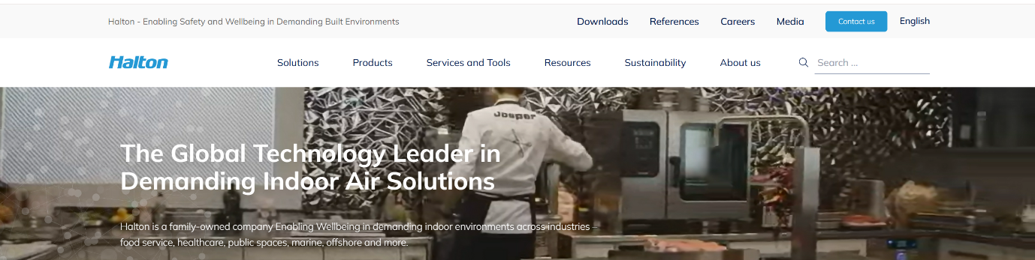
Replace
Halton - Enabling Safety and Wellbeing in Demanding Built Environments
With
Clean air within. A cleaner world beyond.

- AVANTE Logo to be replaced with correct one (sent by wtsp)
- Get Quote button to be removed
- White box to be a little more transparent while sliding down

- Text to be moved to the left side like https://www.halton.com/ website
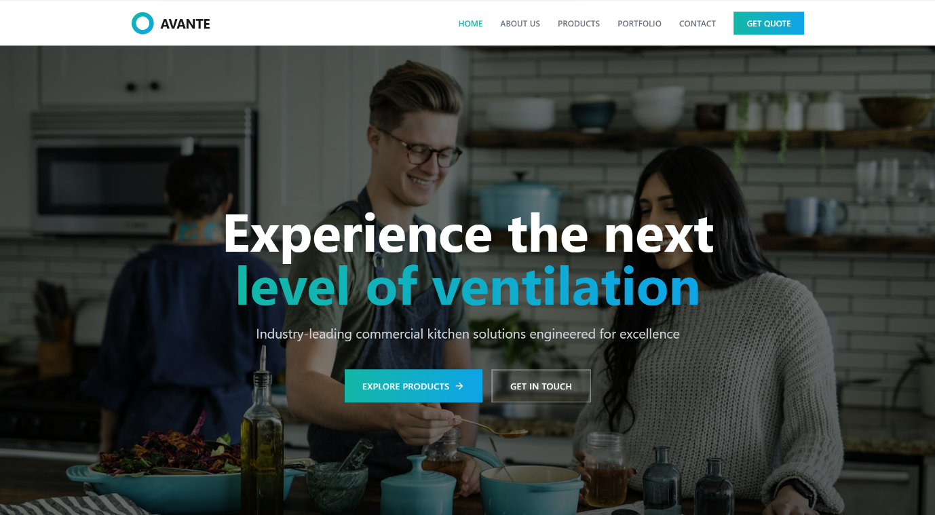
Replace
Experience the next level of ventilation
Industry-leading commercial kitchen solutions engineered for excellence
With
Advanced Kitchen Ventilation & Environmental Solutions
Performance. Safety. Sustainability.

- Tailored Solutions for commercial excellence
Replace
Avante stands as one of the industry-leading suppliers of tailored and integrated solutions in commercial kitchens including kitchen canopies, HVAC systems, demand-control ventilation systems, and fire suppression systems.
Backed by a team of engineers with over 50 years of collective experience across the UK, the Gulf region, and India, we bring unparalleled expertise to every project.
With
Avante is a leading provider of custom-engineered commercial kitchen ventilation and HVAC solutions across food service industries. We deliver fully integrated systems including kitchen canopies, demand control ventilation, fire suppression, ecology units and complete HVAC solutions.
Our solutions are meticulously designed to address the specific operational requirements of every project, that ensure seamless operation and sustained performance throughout the system Lifecycle.
Supported by a team of highly experienced engineers with over 50 years of combined expertise across the UK, the Middle East, and India, Avante brings technical knowledge and industry insight to every project we undertake.

- 4 Buttons instead of 3 (use any icon for now)
250+ Projects Successfully Delivered
20+ Years Engineering Experience
10+ Countries Project Presence
100% Custom Engineered Solutions

- Our Clients section
Replace
Proud to serve leading hospitality and restaurant brands across the region
With
Proud to serve leading hospitality and restaurant brands around the world
-
(Photos will be provided later for the automated sliding)
-
Replace
From luxury hotels to fine dining restaurants, our solutions power the commercial kitchens of the region's most prestigious establishments.
With
Avante ventilation systems are trusted across a wide range of hospitality and commercial foodservice environments.

- Start with About Us page & move “Why choose us” & the “Certifications” sections there
- Start with Contact page & use sales@avanteuae.com for the email

